[**Course Project - Recommendation Report for the CEO**](https://learning.rasmussen.edu/webapps/assignment/uploadAssignment?content_id=_5882958_1&course_id=_65722_1&group_id=&mode=view)

Shaun Pritchard

Rasmussen College

QMB3000

Kevin Watts

May 11, 2020

[**Course Project - Recommendation Report for the CEO**](https://learning.rasmussen.edu/webapps/assignment/uploadAssignment?content_id=_5882958_1&course_id=_65722_1&group_id=&mode=view)

Here is my final recommendation for XYZ Healthcare company to implement the use of Analytics. I believe in order for XYZ Healthcare to move forward into the future that they must take action to implement systems and data-driven processes. As discussed, analytics is the basis of becoming a data-driven company. Although it may seem like a trend. It is a trend that affects influence on all markets globally, and those left without using and incorporating data analytics will initially get left behind.

Over the weeks we have discussed a few parameters to implement new technology and systems into XYZ Healthcare. Here is a recap of our discussion with my current recommendations below.

**Recommendations topics:**

* **Analytics applications**
* **Data quality and reports**
* **Machine/deep learning & Big data Integration**
* **Analytic KPI's and metrics**
* **Additional Requirements**

After a full and thorough consultation, here are the recommendations that I think would best suit XYZ healthcare's needs.

**Analytics & Applications**

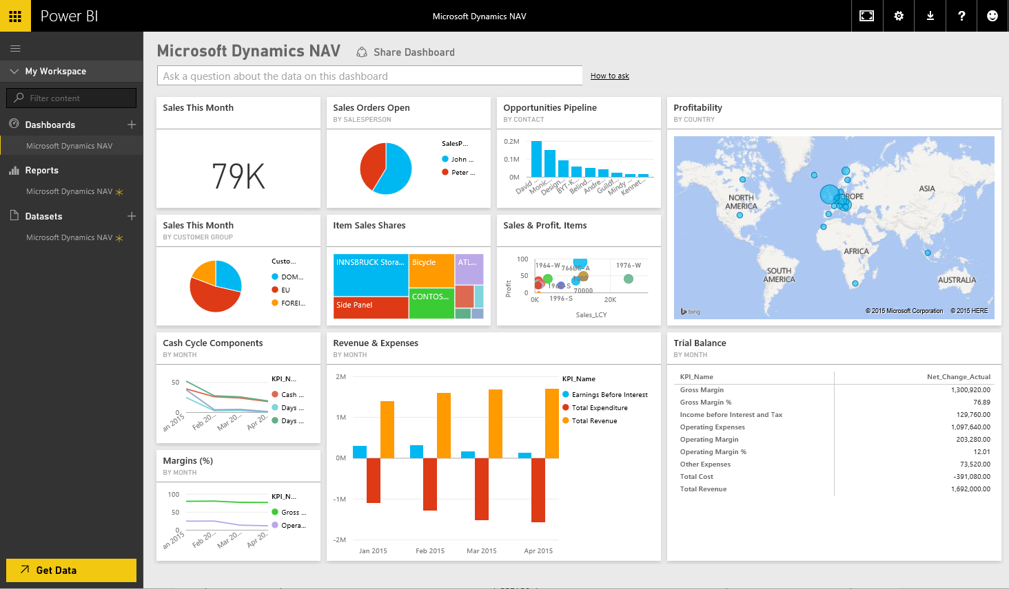

When it comes to analytics program there is no one-size-fits-all. The discrepancy is based on business needs since XYZ Healthcare has shown no prior usage of incorporating analytics or Big Data practices I would have to recommend the implementation of Microsoft Azure and Power BI. Most companies who have not facilitated the integration of data analytics into their company typically spreadsheets and basic word documents. This would be an easy integration to get XYZ Healthcare moving in the right direction as fast as possible. Even considering cost effectiveness and scalability.

* **Implementation of Azure**

Initially, the infrastructure components required using Azure is simple to integrate into modern websites and business for XYZ Healthcare. In order to perform analytics using Azure, we can simply integrate databases a query data to develop an online analytical processing system (OLAP). Azure analytics services will enable XYZ Healthcare to use the full range of data assets to help build transformative and secure analytical solutions at an enterprise scale. Fully managed services like Azure Data Lake Storage Gen2, Data Factory, Databricks, and Azure Synapse Analytics help you easily deploy solutions for BI and reporting, advanced analytics, and real-time analytics. Transforming XYZ Healthcare data into timely insights with Power BI

* **Implementation of Power BI**

Power BI is a powerful analytics tool. That is easy to integrate and creates accurate reports, visualization, and data transformations. Power BI was created by Microsoft and dovetails into Office 365 and Excel. The system lets users evaluate data, create widgets, modify dashboards, develop tables, and rapidly receive data from numerous sources, all in one central platform. Moreover, the system calculates the inventory a business will require during certain time periods based on historical traffic and seasonal patterns. Also, XYZ Healthcare’s real-time data needs.

Power BI is able to send alerts when a company should order additional products. When managing inventory, Power BI can calculate the number of defective items each supplier sends, and any financial losses precipitated by malfunctioning products. Power BI is also able to determine the downtime incurred by defective items to reduce complications in the future.

Microsoft Power BI hosts a standard OLAP platform that connects to SQL servers for multidimensional analysis, enabled via data drilling tools.

**Data quality and reports**

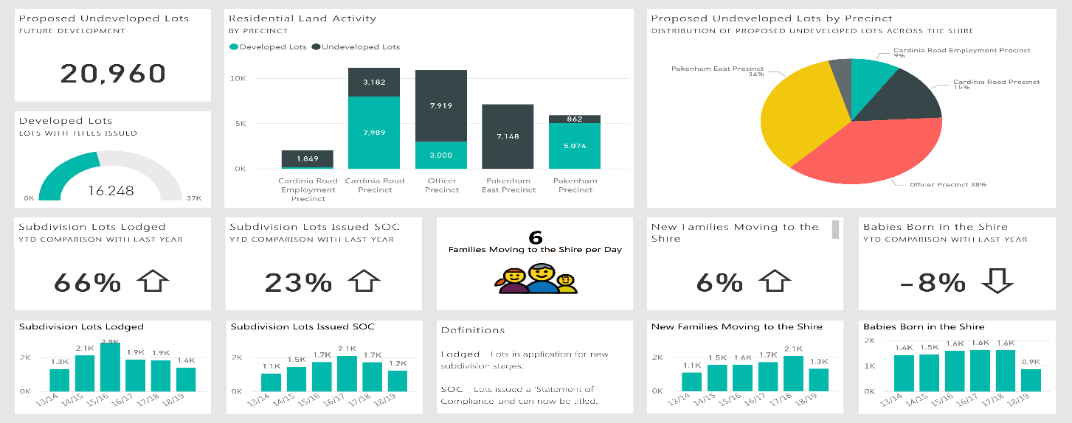

Ensuring data quality is one of the most essential functionalities of completing this whole process. Without clean data or data that is of XYZ Healthcare quality standards. This venture could implement the reverse effect. In Power BI we do not have to worry about this. Data Cleaning functions are implicitly available. Unlike other data visualization tools, users do not need to use DAX functions for cleaning data; rather they can simply click on the 'Transform' tab in Edit Query menu of Power BI, and clean data directly using the available library functions.

Power BI reports can be easily converted into Microsoft Office files, e.g. Word documents and Excel spreadsheets. The program does not support versioning. However plugins and resources to convert reports into PDF for example are standard and not limited.

**Machine/deep learning & Big data Integration:**

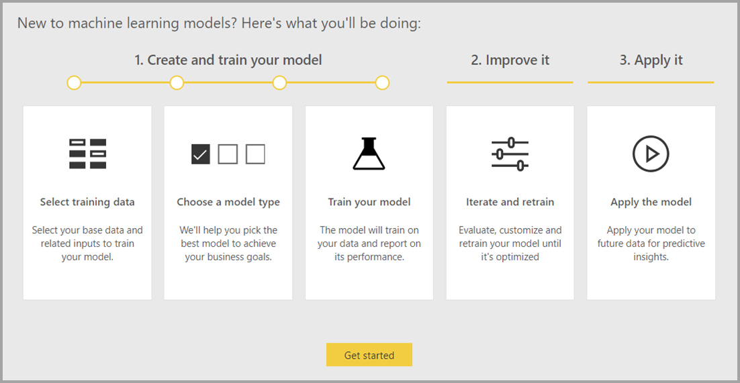

Power BI Dataflows offer a simple and powerful ETL tool that enables analysts to prepare data for further analytics. XYZ Healthcare will need to invest significant effort in data cleansing and preparation, creating datasets that can be used across their organization. AutoML (auto-machine Learning), enables XYZ Healthcare to leverage the data prep effort for building machine learning models directly in Power BI.

With AutoML the data science behind the creation of machine learning models is automated by Power BI, with guardrails to ensure model quality, and visibility to ensure XYZ Healthcare will have full insight into the simple steps used to create your Machine Learning model.

With its multiple linking capabilities within the Microsoft space, Power BI is capable of extracting information from multiple data sources that utilize various formats, combining it into a central database where an analyst can leverage data by common keywords and trends. Additionally, users can eliminate the negative impact of analytical anomalies or narrow down data. Information can be sorted by demographic attributes or geographic regions in order to drill down to the most relevant data for actionable reporting.

**Data Visualization**

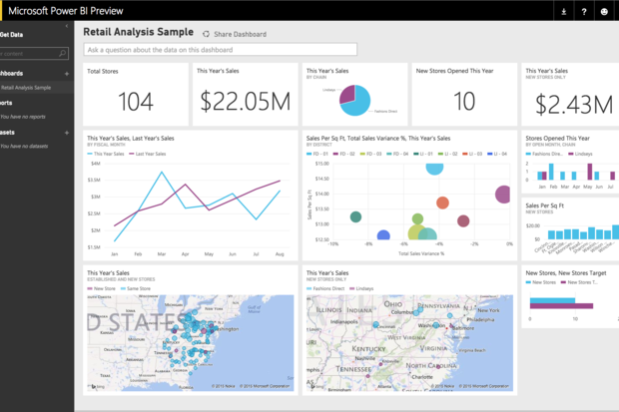

The data visualization features of Microsoft Power BI rest on the concept of ease of use. Drag-and-drop capabilities and an open, customization-focused platform provide a user-friendly tool for report creation. A multitude of visualization options adds to the simplified individuality offered by the system. Additionally, many of the tools share functionality with Microsoft Excel, so the majority of users will be able to learn the data visualization features quickly.

Microsoft Power BI has the best data visualization platform (in my experience) among these systems, mainly due to its user-friendly interface and workflow. While other tools such as Tableau and SAS share many of the same features that are common among most data visualization tools, Power BI’s ease of use really sets it apart.

**Analytic KPI's and metrics**

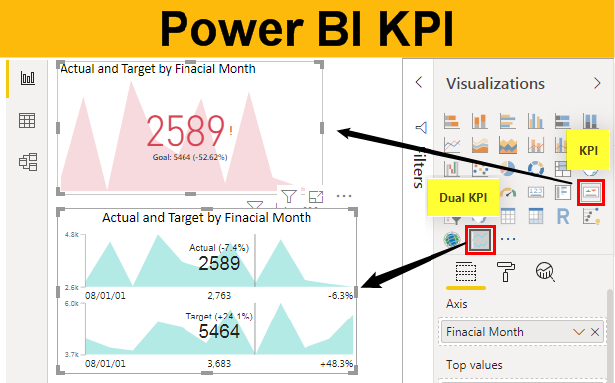

It is important to understand that way needs to develop strategic goals within XYZ Healthcare. Only with these strategic goals in mind can we extract and transform this data into analytic information that can be used for pertinent business decisions. To allocate metrics that will help determine the direction of the company. To make predictions and drive XYZ Healthcare into the future as a data-driven company. Here are some examples of the KPI metrics that XYZ Healthcare will need to take into consideration to implement with the Technologies I have recommended.

**KPI categories to define strategic goals:**

* **Finances**
* **Customers**
* **Employees**

**Financial**

* **Profit and Loss:** Profit and loss reports are one of the simplest and most effective measures of success.
* **Revenue vs. Target:** This is a basic comparison that measures your actual revenue versus what you projected to make. revenue goals.
* **Expenses vs. Budget:** Here XYZ Healthcare can compare your actual overhead costs with your allotted budget.

**Customer**

* **Customer Acquisition Cost (CAC):** This metric essentially tells XYZ Healthcare how much it costs to bring on a new customer.
* **Customer Churn Rate (CCR):**This metric measures the percentage of customers that fail to become a repeat customer or discontinue service during a period of time.
* **Customer Lifetime Value (CLV):**This metric lets XYZ Healthcare measure the total value from a long-term customer relationship.

**Employee**

* **Success of Customer Training:** This essentially shows how effective XYZ Healthcare employee trainings are.
* **Employee Turnover Rate (ETR):** This can be found by dividing the number of employees who have left the company by the average number of employees.
* **Employee Satisfaction:** This can be determined using a multitude of strategies. The easiest way to do so is to create a basic survey.

**Additional Requirements:**

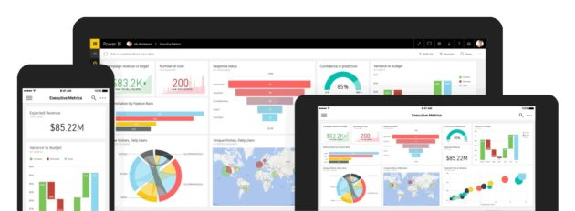

Microsoft Power BI has a network of partner businesses that provide knowledge and consulting services to users. Companies such as Dell, Launch Consulting, Peters & Associates, DB Best Technologies LLC, and over 300 other firms have partnered with Microsoft to bring their benefits to users. In addition to the partner program, Power BI supplies a support network that consists of traditional support resources and community forums, along with educational tools. Guided lessons, sample Power BI files, and informational pieces give users tools for learning the system.

Microsoft Power BI continually adds data sources and embeddable programs. Some of the applications listed on the vendor’s website include Google Analytics, Oracle, Salesforce, GitHub, Facebook, and of course other Microsoft tools such as Excel, SharePoint, and Access.

I believe this would be the best course of action for XYZ healthcare to implement and start applying their data. Putting it to use in this effect and becoming data driven. David, If you have any questions, please feel free to reach out to me to discuss these recommendations further.

# References

Brisaboaa, N. R. (2015). Rank-based strategies for cleaning inconsistent spatial databases. *International Journal of Geographical Information Science*, 26.

Brownlee, J. (2019). *Machine Learning MAstery.* self.

Carnegie Mellon. (2020). *Arthur Samuel's definition of Machine Learning*. Retrieved from https://www.contrib.andrew.cmu.edu/: https://www.contrib.andrew.cmu.edu/

Cragg, J. g. (1994). Making good inferences from bad data. *Canadian Journal of Economics*, 26.

Durcevic, S. (2019, 02 21). *KPI Management And Best Practices: How To Find The Perfect KPI Solutions?* Retrieved from https://www.datapine.com/: https://www.datapine.com/blog/kpi-management-and-best-practices/

Gartner. (2020). *Magic Quadrant for Analytics and Business Intelligence Platforms.* CA: Gartner.

Greene, K. B. (2015). Bad Data States are embracing the promise. *Governing*, 9.

Grime, L. J. (2013). How Much Does Bad Data Cost Your Company? *Journal of Corporate Accounting & Finance* , 4.

Guess, A. (2011). Root Causes of Data Quality Problems. *Journal of Information Science and Engineering* , 1.

Jamshidi, P. (2019). Machine Learning Meets Quantitative Planning:. *2019 IEEE/ACM 14th International Symposium on Software Engineering for Adaptive and Self-Managing Systems (SEAMS)*, 13.

Kirk, A. (2012). *Data Visualization A Successful Design Process.* USA: Packet.

Langkafel, P. (2016). *Big Data in Medical Science and Healthcare Management : Diagnosis, Therapy, Side Effects.* de Gruyter.

Miller, J. D. (2019). *Hands-On Machine Learning with IBM Watson : Leverage IBM Watson to Implement Machine Learning Techniques and Algorithms Using Python.* ebook: Packt Publishing.

Nguyen, T. L. (2019). AI Deep Learning with Convolutional Neural Networks. *Journal of Strategic Innovation & Sustainability*, 12.

Prathipa, J. A. (2020). Stock Market Analytics: Statistical and Machine Learning Techniques. *International Journal of Psychosocial Rehabilitation*, 5.

Spotless Data. (2020). *14 CAUSES OF DATA QUALITY PROBLEMS*. Retrieved from Spotlessdata.com: https://spotlessdata.com/blog/14-causes-data-quality-problems-part-1

Syniti. (2014, 3 24). *The Three Root Causes of Poor Big Data Quality*. Retrieved from syniti.com: https://resources.syniti.com/syniti-blog/the-three-root-causes-of-poor-big-data-quality

TRAN, M., & GINIGE. (2019). Evaluation of Visualisation Techniques for Meaningful Representation of Clinical Classification Data Sets...Health Informatics Conference, Sydney Australia, 2018. *Studies in Health Technology & Informatics*, 7.

W., L. Y. (2006). Journey to Data Quality. *American Psychological Assoc*, 1.